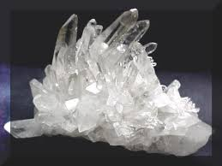
Task 7 :Crystals Investigation

Outcomes: Science Inquiry; Science Understanding: Earth & Space

In groups of 3-4, examine the following images and develop an experiment that makes sugar crystals

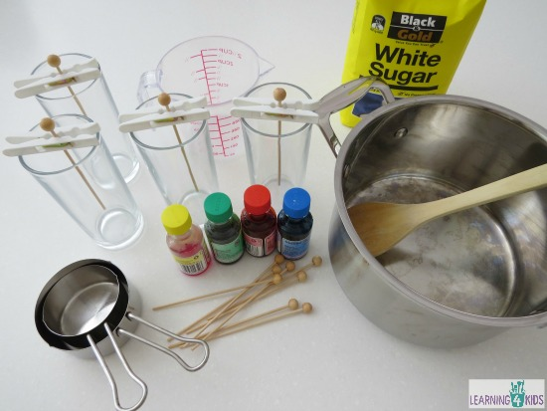

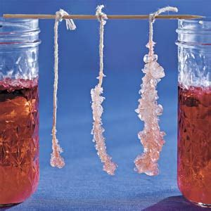

INDIVIDUALLY write a laboratory report for your investigation.

Component | Description | Marks
Title | - Title relevant and concise | 1
Aim and Hypothesis | - Aim is clear and concise  - Hypothesis relates independent and dependent variables | 2
Equipment and Procedure | - Appropriate equipment  - Procedure is detailed and specific  - Diagram is scientific, neat, labelled and appropriately sized | 3
Variables | - Independent variable is identified  - Dependant variable is identified  - 3 controlled variables identified | 3
Results | - Table includes title which relates variables  - Columns relate to independent and dependent variables and include headings with units | 2
Graph | - Graph title relates variables  - Graph type, size and scale appropriate for data  - Axis correct orientation and labelled, including units | 3
Discussion | - Results summarised and patterns identified  - Explanation of results  - Difficulties or sources of error identified | 3
Conclusion | - Summary of findings | 1
 | - Presentation, neatness and literacy | 2
 |  | Total | /20

